FOM 12 Review Resource: Sinusoidal Curves

- On each graph below, write down
- The amplitude
- The sinusoidal axis
- The period
- The range of $f$
- The coordinates of the first maximum point and of the first minimum point.
- The function in the form $f\left(x\right)=a\sin\left(bx\right)°+d$or $f\left(x\right)=a\cos\left(bx\right)°+d$
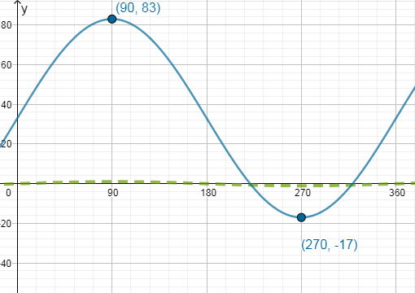 | 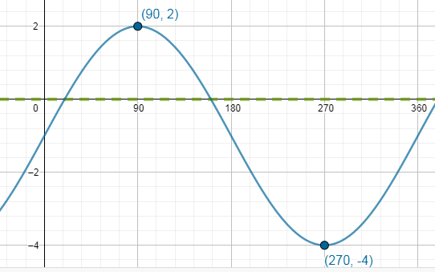
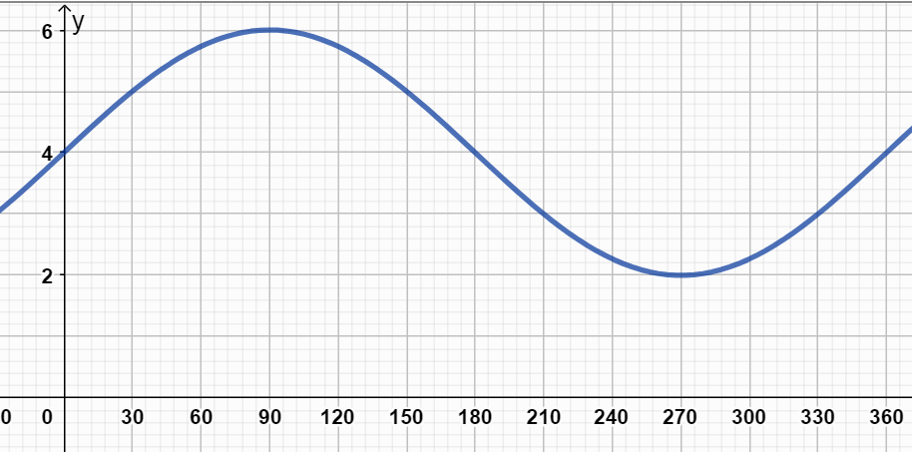 | 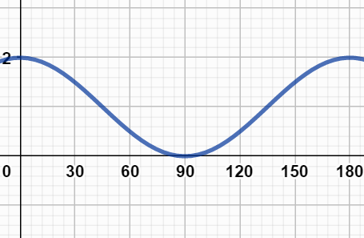
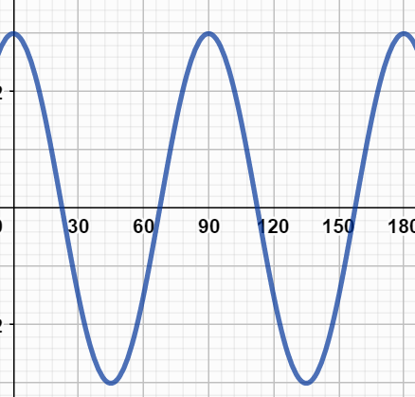 | 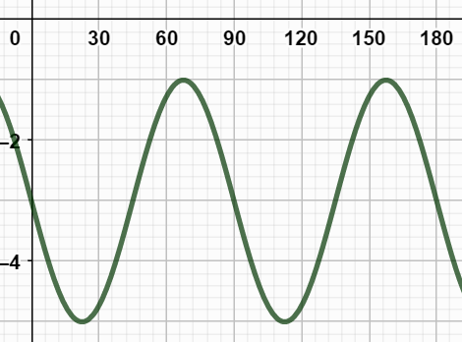

2.
$$f\left(x\right)=3\sin{(4x°)+5}$$  Write down:  - The amplitude  - The sinusoidal axis  - The period  - The range of $f$  - The coordinates of the first maximum point.  - Draw the graphs of the first period of each curve: | $$g\left(x\right)=-\cos{5x°-3}$$  Write down:  - The amplitude  - The sinusoidal axis  - The period  - The range of $f$  - The coordinates of the first maximum point.  - Draw the graphs of the first period of each curve:

- Regression Tool:
A cuckoo clock is hanging on a wall. The table below gives the height of the pendulum above the ground as the clock ticks.
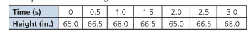
- Plot the data
- Find a sinusoidal model (function) for the data set. Write it down.
(c) Use the model to find the height of the pendulum when t = 2.2 seconds. Is this an example of interpolation or extrapolation?
(d) Use the model to find the height of the pendulum when t = 4.2 seconds. Is this an example of interpolation or extrapolation?

